Group Name:_________________________________

Classify the factors in the picture as either biotic factors or abiotic factors.
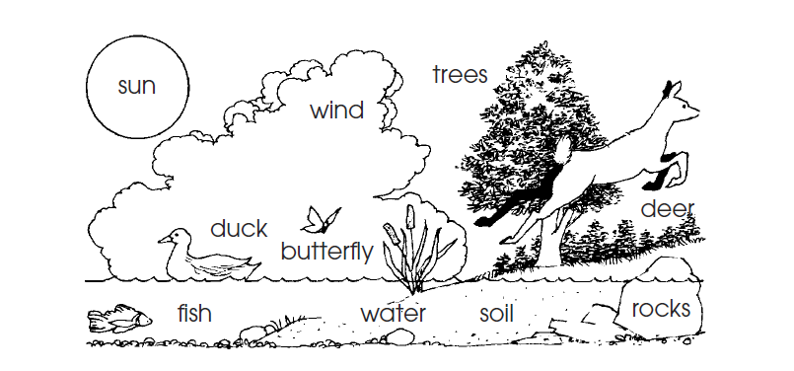

ABIOTIC | BIOTIC

Write A if Abiotic or B for Biotic

_______ Mouse
_______ Rocks
_______ Water
_______ Fish
_______ Paper
_______ Glass
_______ Aluminum
_______ Wooden Ruler

_______ Sand
_______ Clouds
_______ Plastic
_______ Air
_______ Wind
_______ Trees
_______ Soil
_______ Snail

